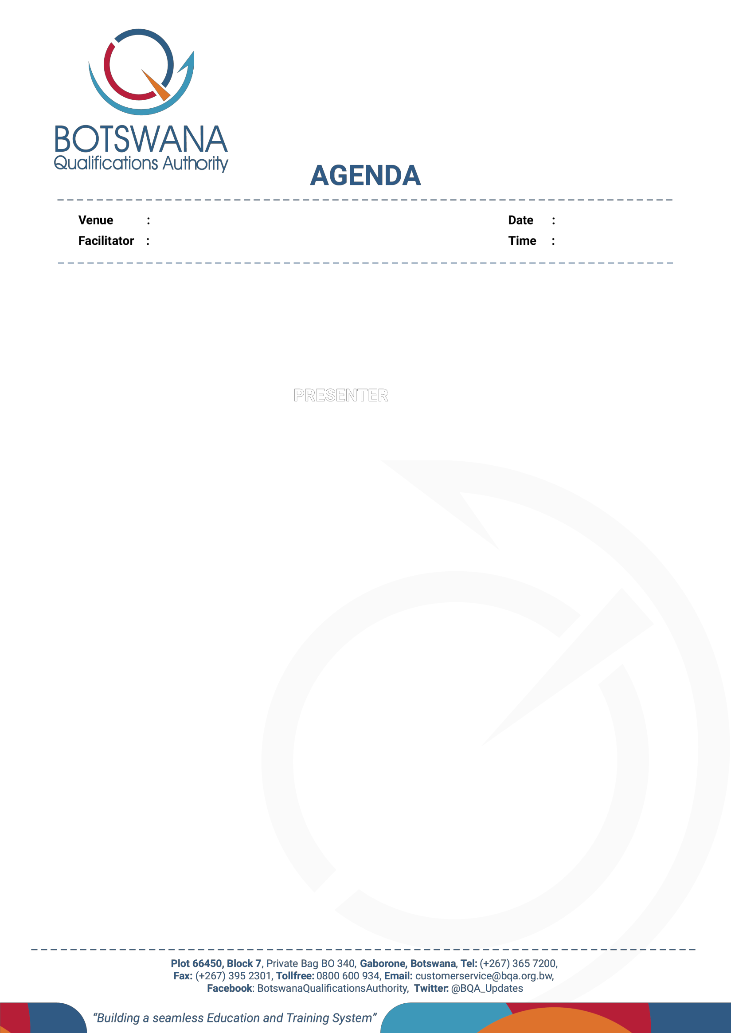

Venue: Gaborone Cresta Lodge
Programme Directors: Mmoloki
Moilwa and Lebogang Noble
Date: 23 - 25 March 2026
Time: 08:00

PROJECT ON REFERENCING THE NCQF TO THE ACQF CAPACITY BUILDING WORKSHOP FOR LOCAL EXPERT TEAM (LET) AND NATIONAL REFERENCING TEAM (NRT)

TIME | ITEM | PRESENTER
DAY 1: 23 March 2026 - Foundations and Framework Understanding

RAPPATEUR: Rebaone Molosiwa and Gape Kobedi
08:00 - 0830 | Arrival of Participants - Registration
08:30 - 08:35 | Prayer | Volunteer
08:35 - 08:45 | Introductions | ALL
08:50 - 09:00 | Welcome and Opening Remarks | Boitumelo Watlhaga  (Acting Chief Executive Officer)
08:50 - 09:00 | - Workshop Objectives  - Project Governance Overview | Ofentse Disang  (Acting Chief Executive Officer)
0900 - 10:00 | Introduction to the Referencing Project  - Overview of the NCQF | Felicitas Balule  (Manager QID)
0900 - 10:00 | - Overview of the ACQF  - Purpose and importance of referencing  - Overview of the ACQF Referencing process | ACQF: Maria Rosenstock

DAY 1: 23 March 2026 - Foundations and Framework Understanding Continues..

10:00 - 10:30 | Health Break | ALL
10:30 - 11:30 | Deep Dive into NCQF and ACQF Structures
10:30 - 11:30 | Detailed review of NCQF components | QIDO: Edward Selelo
10:30 - 11:30 | Overview of ACQF referencing criteria and level descriptors. What has to be compared? | ACQF: Robin Phoolchund
10:30 - 11:30 | Questions, comments and discussion | Participants
11:30 - 12:45 | Demonstrating Links between the Levels of NCQF and ACQF - Technical Approach  - Introduction to the referencing methodology  - Technical tools and templates for mapping - Examples  - Validation criteria and quality assurance standards | ACQF: Maria Rosenstock
12:45 - 14:00 | Lunch Break | ALL
14:00 - 15:30 | Practical Session: Framework Analysis  - Group activity: Analysing sample NCQF and ACQF frameworks (identifying key elements for mapping, documenting findings and discrepancies)  - Group presentations and discussion | Participants split into two Groups  Group 1 Comparison of Levels 1-5  Group 2 Comparison of Levels 6-10
15:30 - 16:30 | Stakeholder Engagement and Validation Processes  - Strategies for effective stakeholder consultations  - Planning validation workshops and feedback collection | ACQF: Robin Phoolchund  (process-side),

DAY 2: 24 March 2026 - Practical Skills and Application
RAPPATEURS: Rebaone Molosiwa and Gape Kobedi
08:30 - 0835 | Prayer | ALL
08:35 - 0845 | Recap of Day 1 and Objectives for Day 2 | Programme Director
08:45 - 10:00 | Preparing the Referencing Report  - Proposed structure and content  - Examples  - Questions and discussion | ACQF: Maria Rosenstock  (providing evidence in the report)
10:00 - 10:30 | Health Break | ALL
10:30 - 12:00 | Hands-On Mapping Exercise  - Using provided templates, in groups, map sample NCQF levels to ACQF levels and document rationale and validation points  - Group presentations and discussion | Participants split in two groups: Group 1: Comparison of levels 1-5  Group 2: Comparison of levels 6-10  Writing narrative and defending the statements.
12:00 - 12:45 | Case Studies and Best Practices  - Review of successful referencing exercises from other countries (ACQF experience to date)  - Lessons learned and common challenges | ACQF: Robin Phoolchund
12:45 - 14:00 | Lunch Break | ALL

DAY 2: 24 March 2026 - Practical Skills and Application Continues…
14:00 - 14:30 | - Quality assurance of the referencing report - checklists | ACQF: Robin Phoolchund
14:30 - 15:30 | Group activity: assessing a sample report against checklist  - Reading a sample of a referencing report  - Presentations and discussion | Participants working in groups
15;30 - 16:30 | Troubleshooting and Addressing Challenges  - Common issues in referencing reports  - Strategies for resolving issues | ACQF: Maria Rosenstock

DAY 3: 25 March 2026 - Validation, Reporting, and Next Steps
RAPPATEURS: Rebaone Molosiwa and Gape Kobedi

08:00 - 08:30 | Arrival of Participants - Registration
08:30 - 0835 | Prayer | ALL
08:35 - 08:45 | Recap of Day 2 and Workshop Objectives | Programme Director
08:45 - 10:00 | Action Planning and Next Steps  - Milestones and timeline  - Roles and responsibilities | Programme Director
10:00 - 10:30 | Health Break
10:30 - 12:00 | Final Q&A and Feedback Session | BQA/ACQF
12:00 - 12:45 | Closing Remarks | ACQF  LET and NRT Chairpersons, Ag DNCQFS
12:25 -14:00 | Lunch Break | ALL

